Michael Recycle
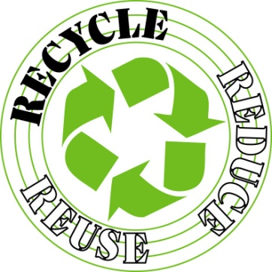By Joshua Seigal
written especially for Fleetville Infant School

Michael recycled
everything:
paper planes
and balls of string.
When mum said
‘put the litter out’,
he’d recycle it all,
without a doubt.
Bits of fluff
and lumps of dirt,
a pair of old shoes
and a very old shirt.
stacks of cardboard,
yoghurt pots,
A pair of sweaty,
disgusting socks.
Bottles, cans
and old flaky books.
But he got
some funny looks
from his very
angry mother
when he tried to recycle
his baby brother.

